-Change all passwords

-create a list of all processes that are running to compare later on in the competition

-disable ipv6 on windows boxes

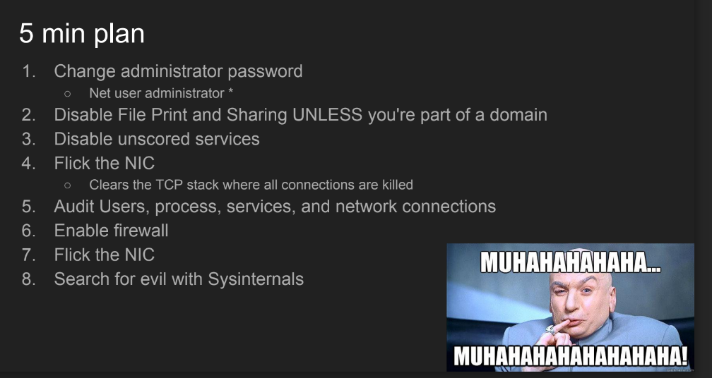

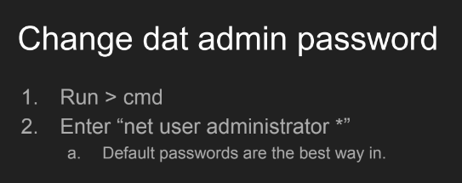

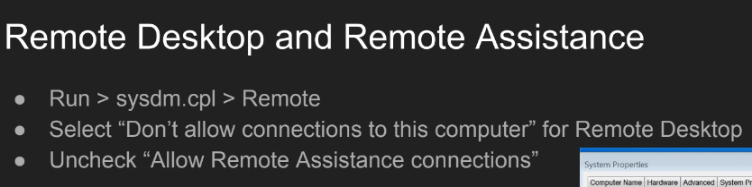

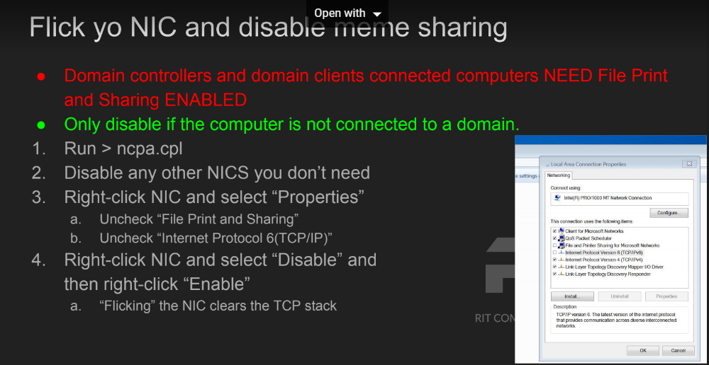

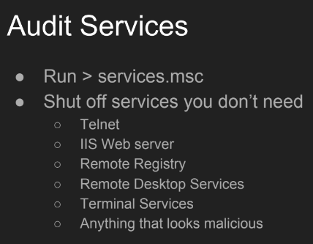

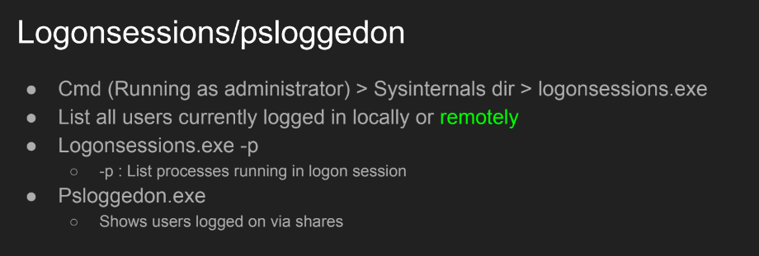

**-Windows**

-Run Windows firewall script

-Disable Power Shell {control panel,

-Disable RDP

-Disable SSH

-Disable Netcat

-make windows host file immutable

-block all netcat connections

**-Linux**

-Run Linux ip-tables script

-Install qps on Linux

-sudo apt-get install aptitude

-sudo aptitude install qps

-qps

-block all netcat connections

-All linux people should have explainshell.com up

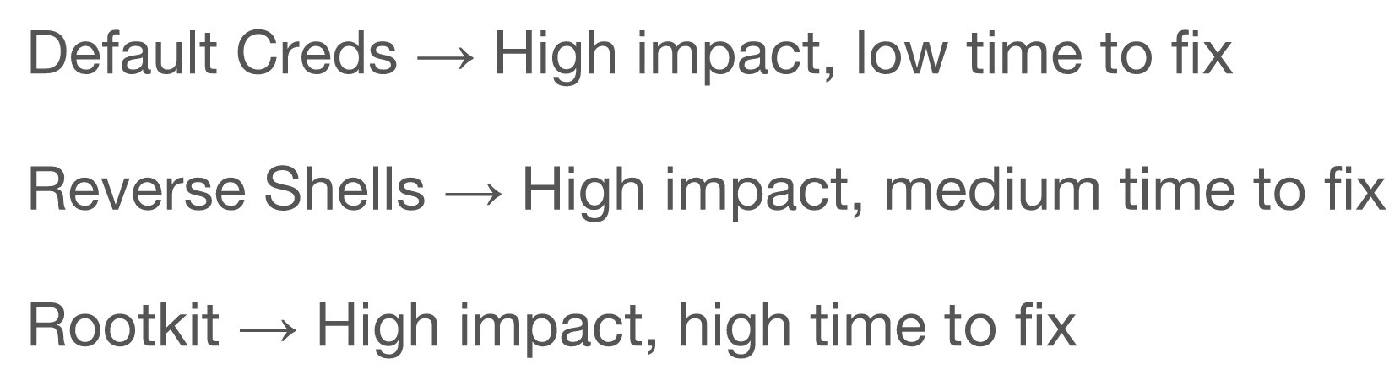

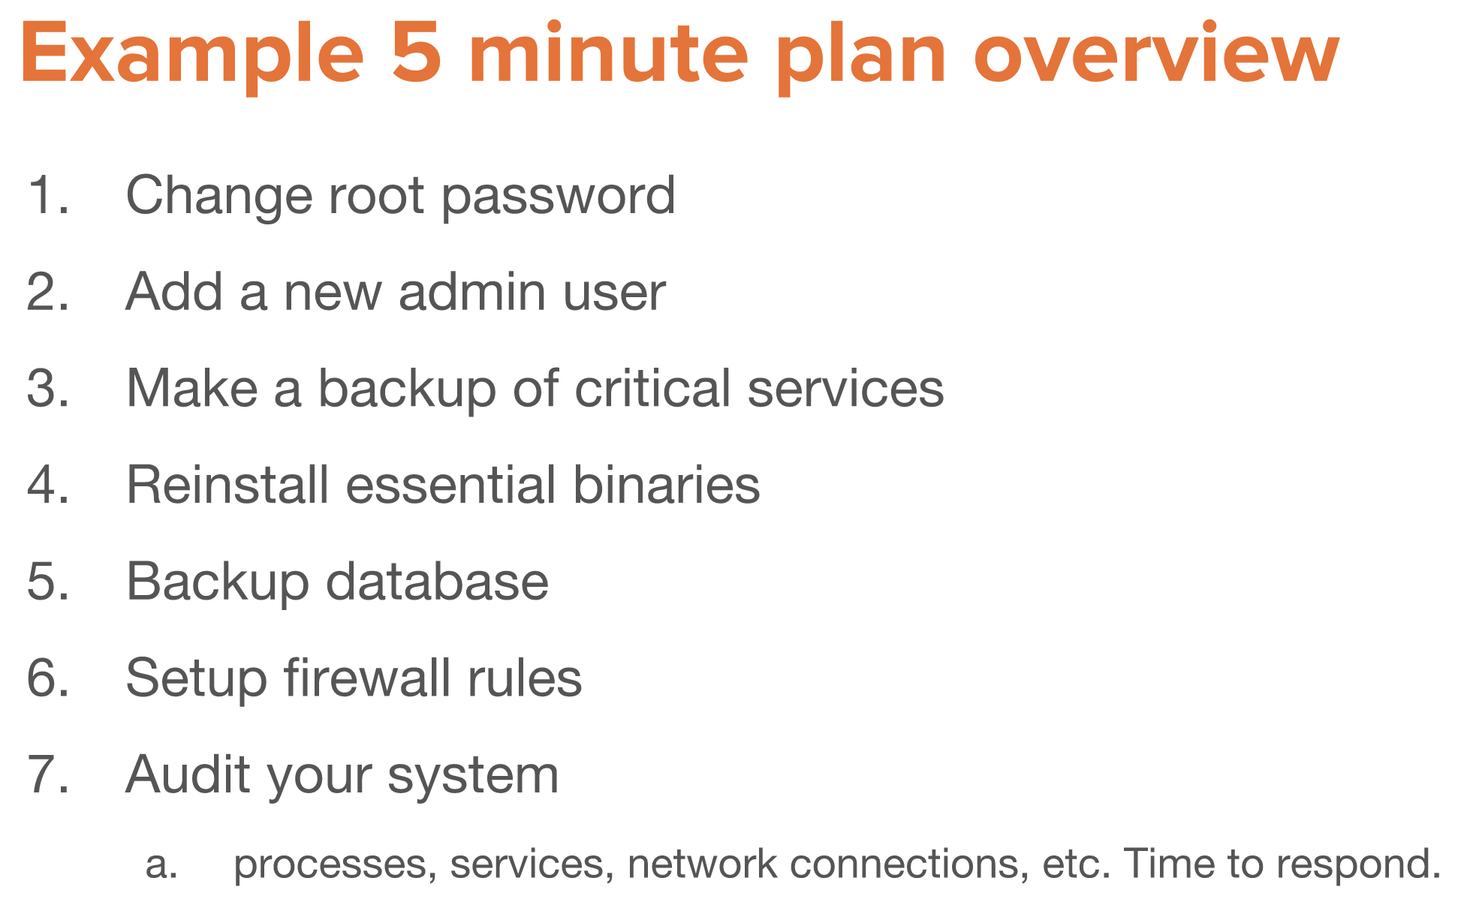

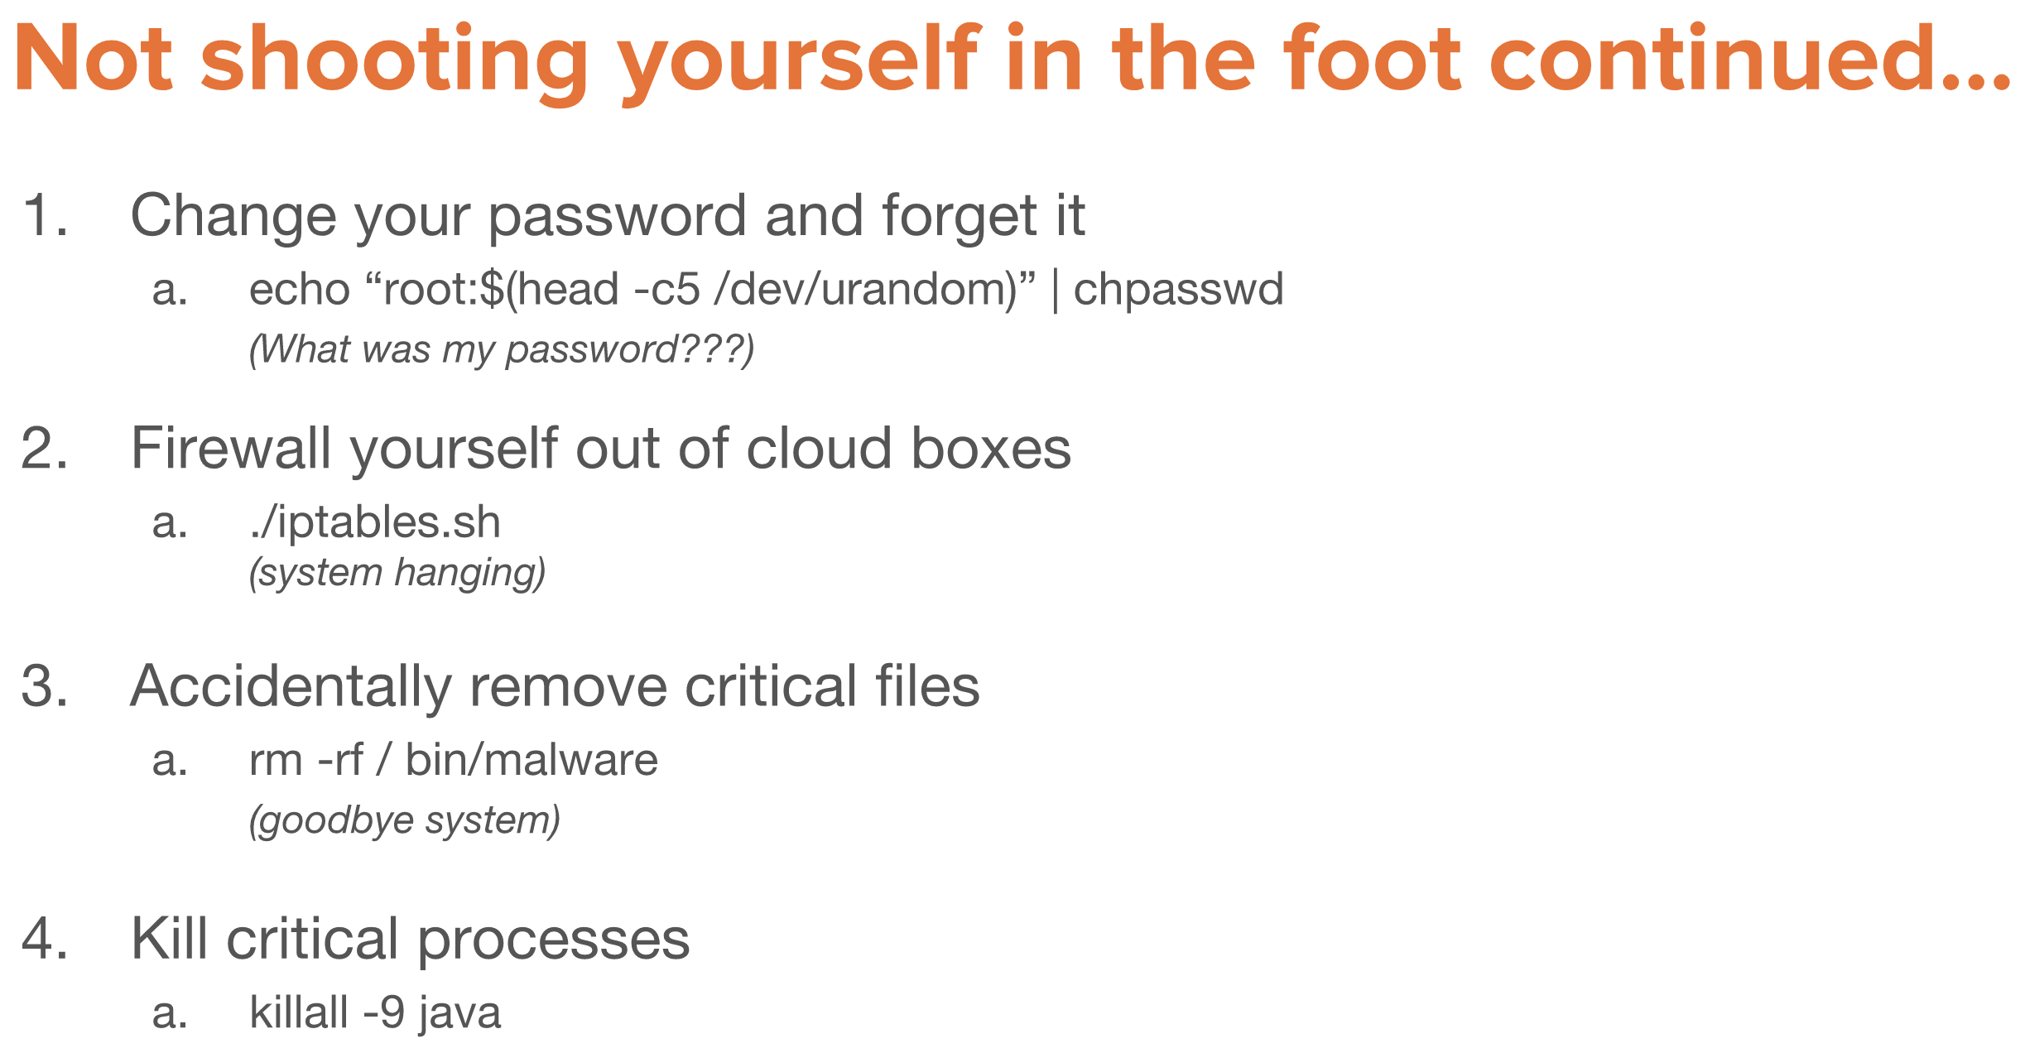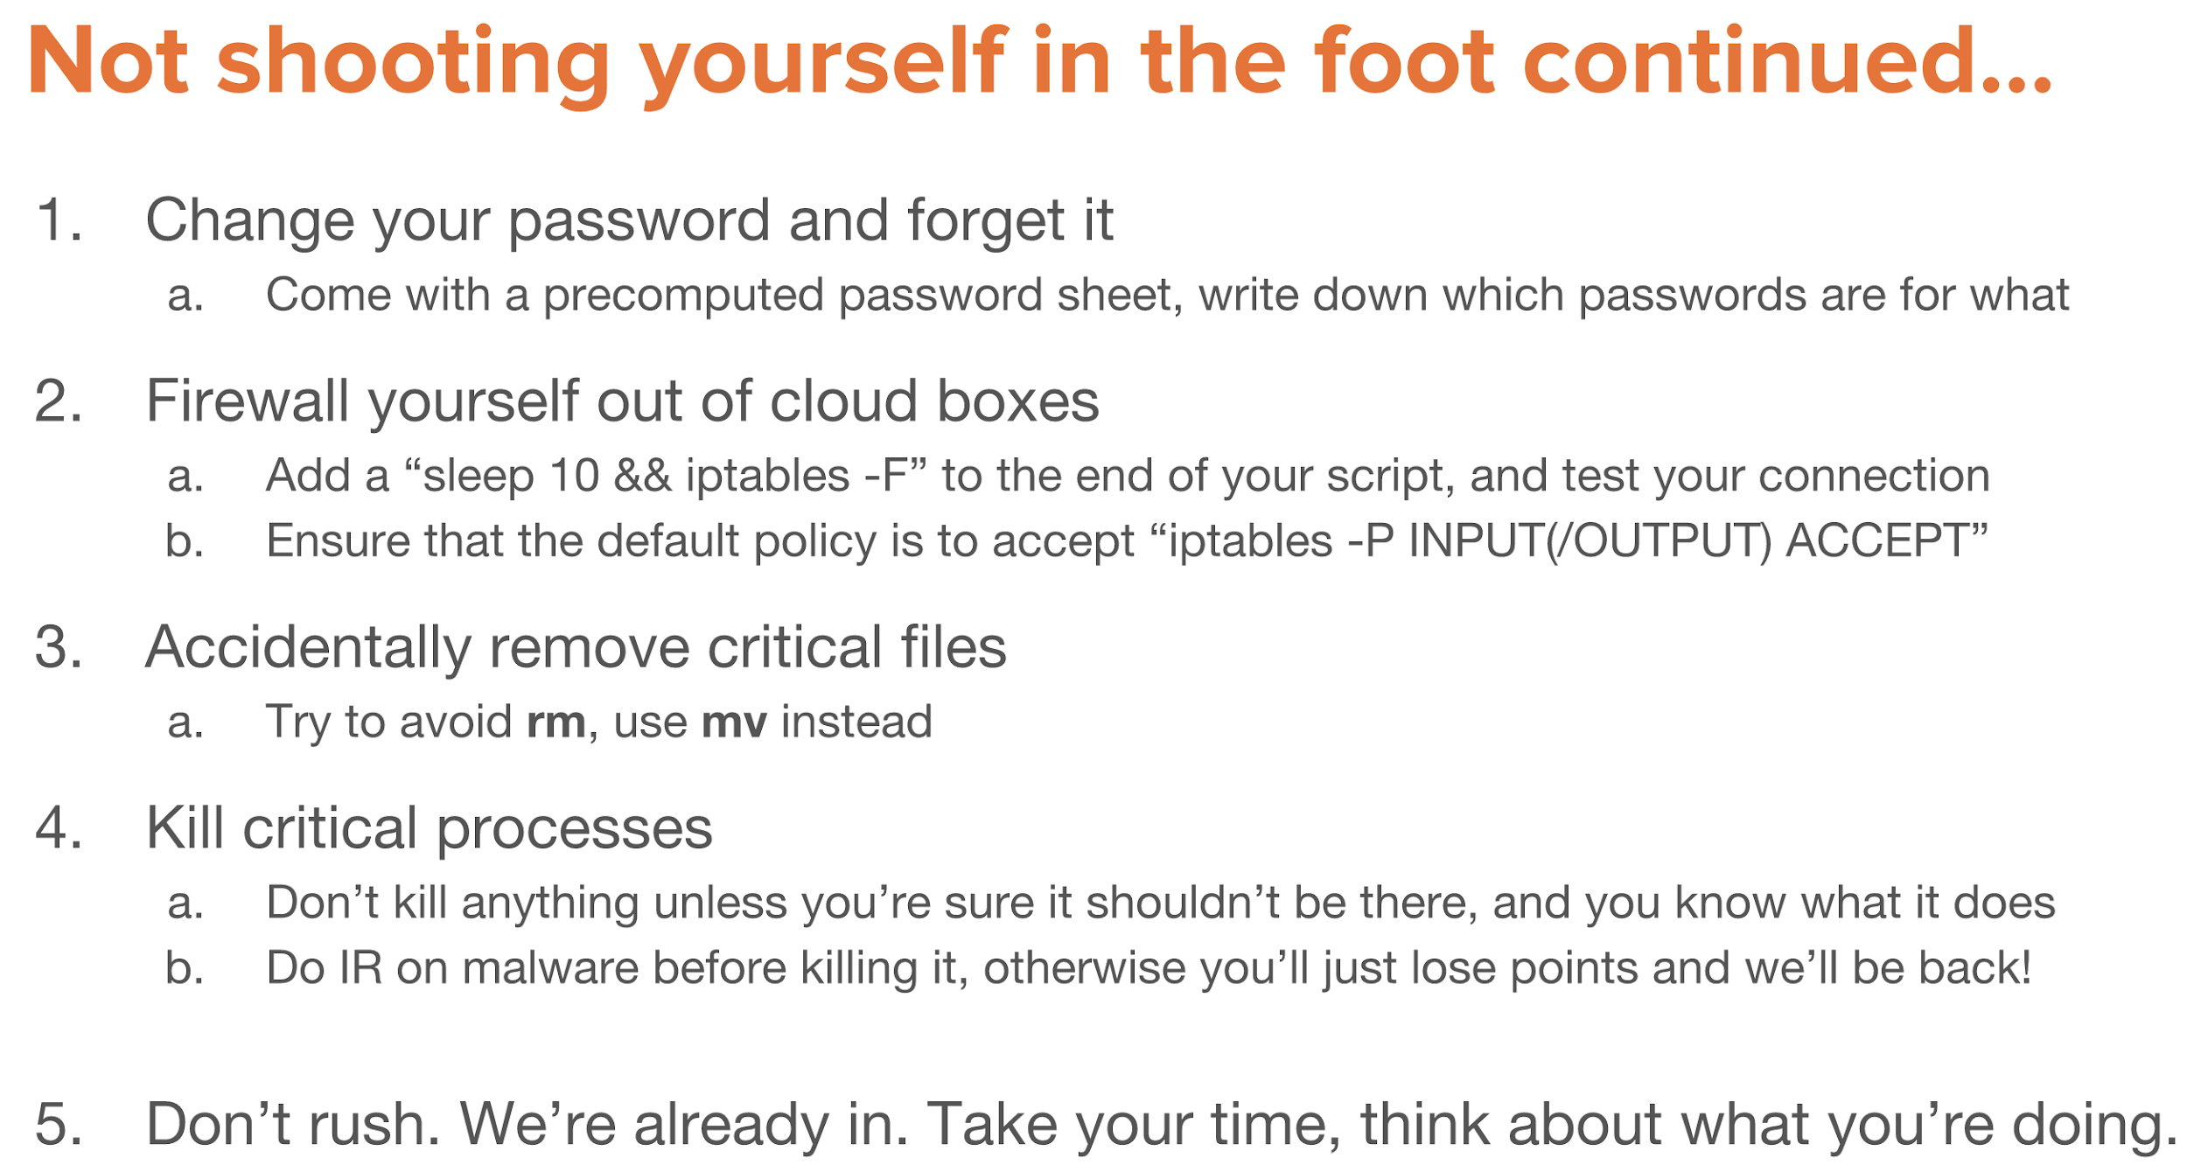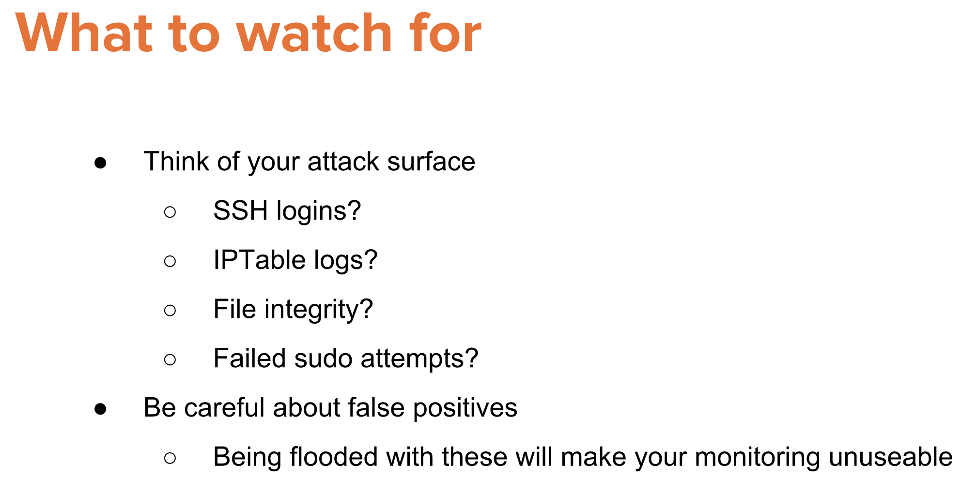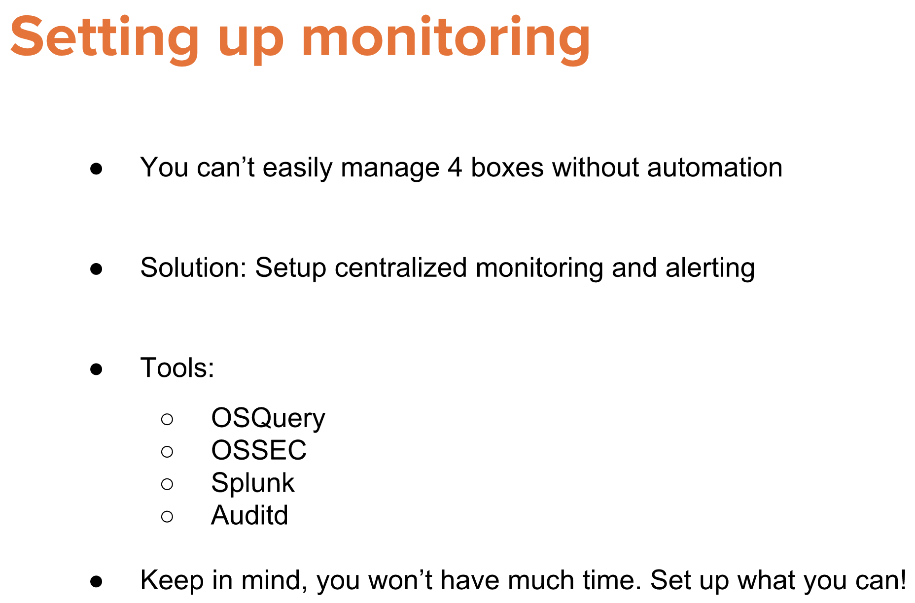

NOTES:  
